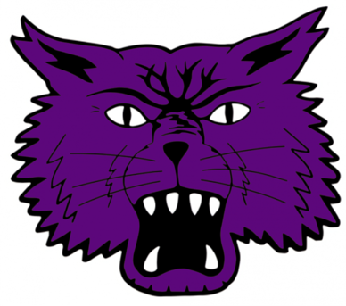
Bearcat Golf Outing
Fundraiser for the
Basketball and Football Programs

When Friday, July 21, 8:15 a.m. Registration
9:00 Shotgun Start. Lunch and awards to follow.
Where Delaware Country Club
Donation $500 per Team
Add ons For purchase – mulligans and skins game
Contests Closest to the pin and longest drive
Awards Winning team - $100 per player, 2nd place - $40 per player
Rain or Shine – No Makeup Date – Donations are Final
Limited to the first 18 teams

Sponsorships Available

Gold Sponsor $1,000 – “Event Sponsor” Signage at registration area, lunch area, on the course, and recognition on social media. Includes 1 team in the event.

Silver Sponsor $750 – Signage on the course as a hole sponsor, signage at the putting green, and recognition on social media. Includes 1 team in the event.

Bronze Sponsor $250 – Signage on the course as a hole sponsor and signage at the putting green.

Hole Sponsor $150 – Signage on the course as a hole sponsor.

Any sponsors can provide giveaways with company logos (tees, golf balls, towels, biz cards, etc).

To secure your team and/or sponsorship, please email the below information to Boys Basketball Coach Justin Ullom JWUllom@gmail.com

-------------------------------------------------------------------------------------------------------------------------------------------------------------------------
2023 Basketball and Football Golf Outing

Email Coach Ullom to secure your sponsorship. Make checks payable to MCHS Boys Basketball and mail to:
MCHS Boys Basketball
C/O Justin Ullom
14327 E CR 150 S
Parker City, IN 47368

Sponsor Information
Company Name | Will you provide yard sign or want one printed? | Email
Contact Name | Phone Number | Address
Email Coach Ullom your company logo if you are wanting a sign printed.
All signs will be black and white 1 sided.

Bearcat Golf Outing
Fundraiser for the
Basketball and Football Programs

When Friday, July 21, 8:15 a.m. Registration
9:00 Shotgun Start. Lunch and awards to follow.
Where Delaware Country Club
Donation $500 per Team
Add ons For purchase – mulligans and skins game
Contests Closest to the pin and longest drive
Awards Winning team - $100 per player, 2nd place - $40 per player
Rain or Shine – No Makeup Date – Donations are Final
Limited to the first 18 teams

-------------------------------------------------------------------------------------------------------------------------------------------------------------------------
2023 Basketball and Football Golf Outing

Email Coach Ullom to secure your spot. Make checks payable to MCHS Boys Basketball and mail to:
MCHS Boys Basketball
C/O Justin Ullom
14327 E CR 150 S
Parker City, IN 47368

Player Information
Player 1 | Player 2 | Player 3 | Player 4

Team Information
Team Leader Name | Phone # | Email

